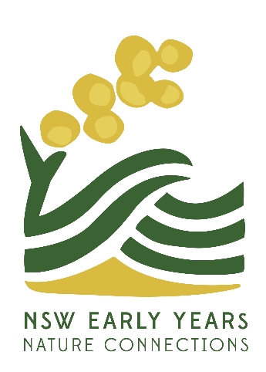
Early Years Nature Connections
The ‘why’ and ‘how’ of a Nature Play program
This training is designed to support early childhood educators who are interested in embedding a rich and comprehensive nature play program in their service.

Whether you are at the beginner stage of your journey or wish to enrich your current practice of taking children ‘out the gate’, this training will give you the tools you require.
Based on contemporary research and practice, the training is presented by Dr Fran Hughes and a group of experienced nature play practitioners who will share their stories and knowledge.
It will be held over two full days in a small group learning format and will provide a balance of practical and theoretical knowledge. Learning will occur in both indoor and outdoor contexts.
Dates: Friday 17th & Saturday 18th March 2023
Time: 9:00am - 3:30pm
Venue: Sydney Olympic Park, Education Annexe Room 1
Cost: $400 (NSW EYNC members), $450 (non-members)
Tickets: https://events.humanitix.com/early-years-nature-connections-the-why-and-how-of-a-nature-play-program
Participants will gain understandings of:
- The importance and value of immersing children in nature on a regular basis.
- How ACECQA (2021) and the EYLF (2009) support nature play.
- The pedagogy of nature play.
- The practicalities of taking children out including risk management and connecting with local community.
- The potential for nature play in a variety of settings - bush, beach, urban, parks.
- How to articulate the importance of nature play to families, colleagues and management.
- Embedding nature play into the service philosophy.
- The importance of engaging with First Nations Peoples, their communities and knowledges.
- The connection between nature and sustainability.
- The rights of all children to play in nature.

